Secure Architecture Report And Recommendations
Premium House Lights Inc.

Created by:
Shawn Perreault
For:
Lighthouse Labs
Week 10 Project

Table of Contents

Executive Summary 1

Security Architecture Recommendations 1-3

Company Policies 4

Network Topology 5

Incident Response plan 6

NIST Controls 7-8

Citations 8

Executive Summary

Introduction:

This Report is designed as a comprehensive guide to address and identify the current security architecture and threat landscape, to provide a brief overview of the current security landscape, the goals of the security architecture, and a summary of the recommendations for The Premium House Lights Inc. Company.

Current Security Landscape:

Based upon assessments of the current security architecture. There are notable weaknesses, vulnerabilities and network design flaws that need to be addressed improving the overall security posture to enable the organization to operate safely and maintain business continuity. The network architecture is insecure. If in the event of a breach, an attacker would have access to all information as the servers are not segmented. There are no port filter rules which do not control what services are available on which ports giving access further in the event of an attack. All traffic is on Vlan 1 which allows each device to communicate with any other device on the network. There is no spanning tree enabled which can lead to network exhaustion. DHCP snooping is not enabled which could allow a rogue DHCP server to connect and gain access to data. The private payment network is directly connected to all servers without any firewall.

Security Architecture Goals:

Firstly, when dealing with Personal Identifiable Information and Credit or Payment Information in Ontario an organization must conform to specific rules and be compliant under the following regulations. PIPEDA, PCI DSS,CASL,DPA. If dealing with customers from Europe the organization must be GDPR compliant. There are rules that also govern specific network architecture designs, controls and industry best practices to protect data, an organization and the people dealing with them. In addition to federal laws, Ontario has specific requirements for reporting data breaches. Organizations must notify affected individuals and the Office of the Information and Privacy Commissioner of Ontario (IPC) when a data breach involving payment information occurs. Although NIST recommendations are not mandatory, they provide excellent suggestions of measures and controls to keep data secure and maintain an individuals privacy when dealing with an organization. Following these laws and recommendations will foster growth while aligning with regulatory requirements.

Security Architecture Recommendations

Data Encryption:

Standard encryption programs for PCI DSS are in place to ensure that consumers personal and credit card information are protected while in use and being stored. While the data is being transferred it must be using the TLS protocol v1.2. While data is at rest and being stored in server’s, PCI DSS mandates the use of AES 128 bit encryption howerever there are stronger types like 256 up to 1024
Identity Access Management
1
Endpoint Security:

All user operated endpoint devices on a network should be authenticated with strong passwords with a minimum length of 12 characters and be rotated monthly . This must be combine with 2 factor authentication.

No DHCP snooping enabled:

Enabling DHCP snooping help prevent rogue servers from connecting and distributing IP addresses on a network. Without DHCP snooping, anyone can set up a rogue DHCP server, which can lead to IP address conflicts, network connectivity issues, and potentially malicious activity. Unauthorized DHCP servers can distribute incorrect DNS or gateway settings, redirecting traffic through malicious servers or potentially eavesdrop on network traffic. It also reduces the risk of man in the middle attacks.

All Ports-VLAN 1

VLAN’s offer network segmentation by breaking down large networks into small portions to control traffic flow increasing security. The isolation of traffic between devices helps to troubleshoot problems as well as keeping specific departments separated preventing communication between devices in an organization.

No Spanning Tree Protocol:

Enabling STP prevents network loops by identifying and blocking redundant paths on a network.
Network loops can lead to to excessive traffic and broadcast storms causing downtime and network outages.

Virtual Standby Router:

A virtual standby router creates redundancy in a network in the event of a router failure.
It maintains availability and connectivity of the network in case of software issues or hardware failure assuming the original IP as the gateway. A virtual standby router can also act as load balancer and help distribute the traffic.

Port Filtering:

It is important to configure your routers, switches and firewalls on a network. Port filtering allows organizations to control which services and applications can communicate over the network. By blocking certain ports, organizations can restrict access to sensitive systems and data, preventing unauthorized users or malicious software from gaining access.

2
Firewall:

By adding an additional firewall at the payment gateway, we can further filter incoming and outgoing traffic. It is important to protect any sensitive information using a firewall to prevent a cyber attack and maintain compliance. Log and traffic monitoring are also a great feature to a firewall continuosly observe the data that travels through it.

Uninterrupted Power Supply:

The new network infrastructure should have and uninterrupted power supply for the web server and payment management system offering uninterrupted service and availability.

New Company Network Policies and Best Practices

The new company network infrastructure can be hardened making a few simple changes that would greatly benefit the organization and be somewhat cost effective.

- Separate vlans for personnel accessing the database or any file share servers. The use of VLANS for segmentation is critical to keep specific traffic and devices seperate and adds another layer of security.

- Only financial departments that need access to the payment gateway or manager’s making financial changes to products need to have access and should follow least privilege access policies as well as proper authentication methods.

- Identity and access management best practices on the network allow only those with the necessary need to access critical data and configurations on the network. This includes role based access that requires 2 factor authentication for the use os applications and sensitive file systems on the network.

- Data categorization is an integral part of keeping sensitive data segregated and stored safely. By categorizing data and securely encrypting data with a minimum of AES 128 bit encryption, data at rest can safe in the event of a data breach . If data is ex filtrated it will be useless to a threat actor thus protecting the consumer’s personal information, company trade secrets or employee records.

- Auditing of third-party vendors or partners, documentation related to their security assessments, network infrastructure audits, or certifications can provide insight into the security measures implemented by these entities. As a primary payment gateway it is important to assess and audit the third party security posture and practices when directly tied to your organization.

- Installing an intrusion detection system on the network can add another layer of security and enhance the current security posture by detecting threats, anomalous traffic and offer better monitoring capabilities. It also offer capabilities to help with scalability as the company changes and grows

3
Current Network Topology
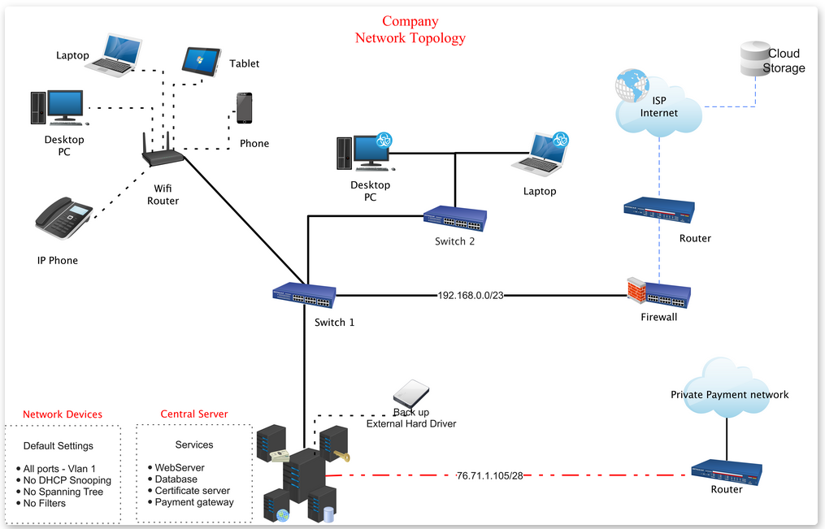

New Network Topology
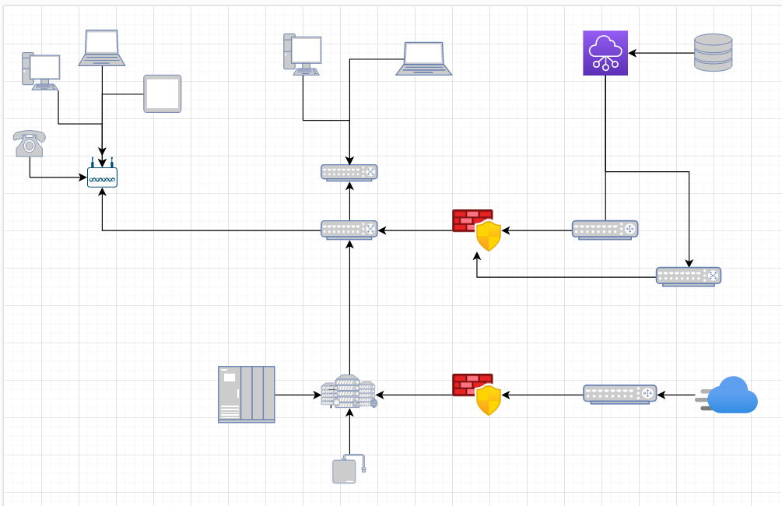
4

Incident Response Plan for
1. Incident Categorization:
Incidents can be categorized into three main types: Internal, External, and Industry-Specific.
Internal Incidents:
- Insider threats
- User misuse/phishing targets
External Incidents:
- Cyber-Attacks
- Ddos, SQL injection
Industry-Specific Incidents:
- Fraud
- Data theft
- Ransomware attacks
2. Incident Response Team:
- Incident Response Team should be formed, consisting of representatives from Operational Technology Team, IT Security Team, Executive Leadership, and Legal Department.
- External stakeholders, such as regulatory agencies and law enforcement, may also be involved in incident response efforts.
3. Incident Identification and Reporting:
- Implement monitoring systems to identify incidents promptly.
- Employees and customers should be encouraged to report incidents to the designated CSIRT contacts.
4. Incident Handling Process:
- Upon identification of an incident, the CSIRT should immediately assess its severity and impact.
- The CSIRT should follow predefined response procedures based on the incident type.
- For Cyber attacks, follow the Cyber security incident response plan.

5. Communication and Notification:
- Maintain clear communication channels within the CSIRT and with external stakeholders using a predefined format like broadcast message to CSIRT members on company phones.
- Notify regulatory agencies, and affected customers about significant incidents.
5
- The Executive Leadership should be informed promptly to coordinate resource allocation and decision-making.
6. Incident Mitigation and Recovery:
- Take immediate action to mitigate the impact of the incident.
- Implement disaster recovery and business continuity plans to restore operations.
- In case of cyber-attacks, follow the incident response procedures for containment, eradication, and recovery.
7. Post-Incident Analysis:
- Conduct a thorough post-incident analysis to understand the root cause and lessons learned.
- Use the analysis to improve incident response processes and preventive measures.
8. Regulatory Compliance:
- Ensure compliance with relevant federal and provincial laws and regulations governing the PCI industry.
- Maintain accurate incident records and reporting to regulatory authorities as required.
9. Industry-Specific Incident Preparedness:
- Develop specific response plans for industry-specific incidents like Data theft and Ransomware attacks etc.
- Conduct regular training and exercises to test the response readiness of the organization.
10. Public Relations and Customer Support:
- Maintain a transparent and timely communication strategy with the public and customers during incidents.
- Provide clear instructions to customers on mitigation measures and expected restoration timelines to restore full operations and business continuity
11. Incident Documentation and Reporting:
- Maintain detailed and elaborate incident documentation, including details of the incident, response actions, and outcomes. Include times,
- Generate incident reports for internal review and for regulatory agencies if required.
12. Incident Review and Continuous Improvement:
- Regularly review the effectiveness of the incident response plan.
- Make necessary updates based on lessons learned from incidents and industry best practices.

6

NIST 800-53 Control Recommendations

Access Control (AC)
- AC-3: Access Enforcement
  - Description: Control access to information systems through the enforcement of access policies.
  - Alignment: Implement strong access controls to address network architecture weaknesses and vulnerabilities.

Audit and Accountability (AU)
- AU-2: Audit Events
  - Description: Generate audit records for events and actions.
  - Alignment: Ensure audit logs are generated for all relevant security events, including network access and configuration changes.
- AU-6: Audit Review, Analysis, and Reporting
  - Description: Review and analyze audit logs for security events.
  - Alignment: Regularly review and analyze audit logs to identify security issues.

Configuration Management (CM)
- CM-7: Least Functionality
  - Description: Implement the principle of least functionality by configuring systems to provide only essential capabilities.
  - Alignment: Ensure that systems and network configurations are minimal and do not expose unnecessary services.

System and Communications Protection (SC)
- SC-7: Boundary Protection
  - Description: Control and monitor communications at the external boundary of the organization.
  - Alignment: Implement port filtering and firewall controls at the payment gateway.

Incident Response (IR)
- IR-1: Incident Response Policy and Procedures
  - Description: Develop and implement an incident response policy and procedures.
  - Alignment: Establish incident response policies and procedures to respond effectively to security incidents.
- IR-4: Incident Handling
  - Description: Establish an incident response capability.
  - Alignment: Develop an incident response team and capabilities to handle security incidents. 7
- IR-5: Incident Monitoring
  - Description: Continuously monitor for and detect security incidents.
  - Alignment: Implement monitoring systems to detect security incidents promptly.
- IR-6: Incident Reporting
  - Description: Report security incidents to designated authorities and support response actions.
  - Alignment: Encourage employees and customers to report incidents and establish reporting procedures.
- IR-8: Incident Response Plan
  - Description: Develop and maintain an incident response plan.
  - Alignment: Create an incident response plan that outlines procedures for responding to different incident types.
- IR-9: Information Handling and Sharing
  - Description: Coordinate incident handling with external organizations.
  - Alignment: Establish communication channels with regulatory agencies and external stakeholders for incident coordination.

Citations:

Microsoft Support https://support.microsoft.com/en-us
Draw.io tools https://www.drawio.com/
Lighthouse Labs https://cyber.compass.lighthouselabs.ca
NIST 800-53 SP Security and Privacy Controls for Information Systems and Organizations
https://csrc.nist.gov/pubs/sp/800/53/r5/upd1/final

8

